

SM6P07NI Digital Media Project

20% Report

2025-26 Autumn

Student Name: Jun Sang Subba
London Met ID: 23048293
College ID: NP01MM4A230014
Internal Supervisor: Arati Shilpakar
External Supervisor: Saugat Basnet
Assignment Due Date: Wednesday, May 20, 2026
Assignment Submission Date: Wednesday, May 20, 2026

I confirm that I understand my coursework needs to be submitted online via Google Classroom under the relevant module page before the deadline in order for my assignment to be accepted and marked. I am fully aware that late submissions will be treated as non-submission and a marks of zero will be awarded.

Abstract
This project is all about creating a captivating Product Shoot Television Commercial (TVC) for an MBT water bottle. The goal is to showcase its standout features like portability, eco-friendly design, a built-in straw, and its overall visual appeal, all while presenting it as a stylish everyday item. Our approach is backed by thorough research into various aspects such as editing, sound design, cinematography, lighting, colour theory, and emotional engagement, which guided both our creative and technical choices throughout the production journey. Techniques like dynamic camera movements, quick editing, controlled lighting, and colour grading to ensure the commercial is visually striking and professional were implemented. The project follows a well-organized workflow that includes pre-production, production, and post-production phases, with tweaks made to enhance realism by incorporating outdoor lifestyle scenes. Aimed primarily at digital platforms like YouTube and Instagram, this TVC is designed for a modern audience aged 16 to 35. Its effectiveness was evaluated through user testing and feedback, which showed that the the product’s value while applying strong media production principles was successfully communicated.

Table of Contents
1. Introduction 1
1.1 Topic 1
1.2 Area of Research 1
1.2.1 Editing Theory 2
1.2.2 Sound Theory 3
1.2.3 Camera Theory 4
1.2.4 Lighting Theory 5
1.2.5 Emotional Influence and Consumer Engagement 6
1.2.6 Colour Theory and Brand Identity 7
1.2.7 Visual Storytelling in Product Advertising 8
2. Aims of Project 9
3. Target Audience 10
5. Technologies Employed 13
5.1 Davinci Resolve 13
5.2 Adobe Premiere Pro 13
5.3 Adobe After Effects 14
6. Project Plan 15
7. Production Phases 17
7.1 Pre-production 17
7.1.1 Script 17
7.1.2 Storyboard 17
7.2 Production 18
7.3 Post-production 19
8. Resources 21
9. User Testing & Findings 22
10. Conclusion 23
11. References 24
12. Bibliography 25
13. Appendix 27

Table of Figures
Figure 1: Editing Theory (Deguzman, 2021) 2
Figure 2: Sound Design Theory (Hibbard, 2014) 3
Figure 3: Camera Theory (Netti_Nu_Nu, n.d.) 4
Figure 4: Lighting Theory (Lannom, 2020) 5
Figure 5: Emotional Influence and Consumer Engagement Theory 6
Figure 6: Colour Theory (codefinity, n.d.) 7
Figure 7: Visual Storytelling Theory (Skill Forges, 2023) 8
Figure 8: Age Group Survey 11
Figure 9: Gender Group Survey 11
Figure 10: Occupation Group Survey 12
Figure 11: Personal Question Survey 12
Figure 12: Thumbnail of Grind: This is better coffee 13
Figure 13: Thumbnail of a Cinematic Water Bottle Commercial 14
Figure 14: Logo of Davinci Resolve 15
Figure 15: Logo of Adobe Premiere Pro 15
Figure 16: Logo of Adobe After Effects 16
Figure 17: Old Gantt Charrt 17
Figure 18: New Gantt Chart 18
Figure 19: Colour Grading in Davinci Resolve 21
Figure 20: Editing in Adobe Premiere Pro 22
Figure 21: Old Gantt Chart 29
Figure 22: New Gantt Chart 29

1. Introduction

1.1 Topic
The project is all about creating a Product Shoot Television Commercial (TVC) for an insulated water bottle from the MBT brand. This commercial aims to showcase the bottle’s standout features, like its eco-friendly design, portability, built-in straw, and a variety of colour options. The goal is to present the product not just as a practical item, but as a stylish accessory that fits seamlessly into everyday life, whether you’re going the gym, working at the office, or enjoying outdoor adventures like hiking.
The TVC will blend different visual styles, mixing high-energy, fast-paced sequences with slower, more relaxed moments to keep viewers engaged. Its length is about 50 to 60 seconds and will primarily target digital platforms like YouTube and Instagram, where eye-catching, short-form content thrives. By featuring the product in various real-life situations, the project aims to highlight its versatility and practicality while ensuring a polished and visually appealing presentation.

1.2 Area of Research
A Product Shoot TVC is all about merging together visual storytelling, technical know-how, and an insight to convey a brand’s message in just a few seconds. Instead of merely showcasing a product, it combines composition, lighting, colour, movement, and sound to forge an emotional bond with the audience. This project was made thorough research into digital media production and product advertising, diving deep into how these elements combine to create captivating and convincing content. key areas like cinematography, lighting, editing, sound design, and consumer psychology were explored, all of which shaped the creative and technical choices made during the production journey.

1.2.1 Editing Theory
Editing plays a crucial role in Product Shoot TVCs because it structures the pacing, clarity, and focus for the audience. Techniques like straight cuts help maintain continuity, while match cuts create seamless visual transitions between shots (Deguzman, 2021). In the world of short-form advertising, quick and precise editing is key to keeping viewers engaged, showcasing important product features, and making sure the message comes across clearly, all within a tight timeframe. (Abreu, 2022)
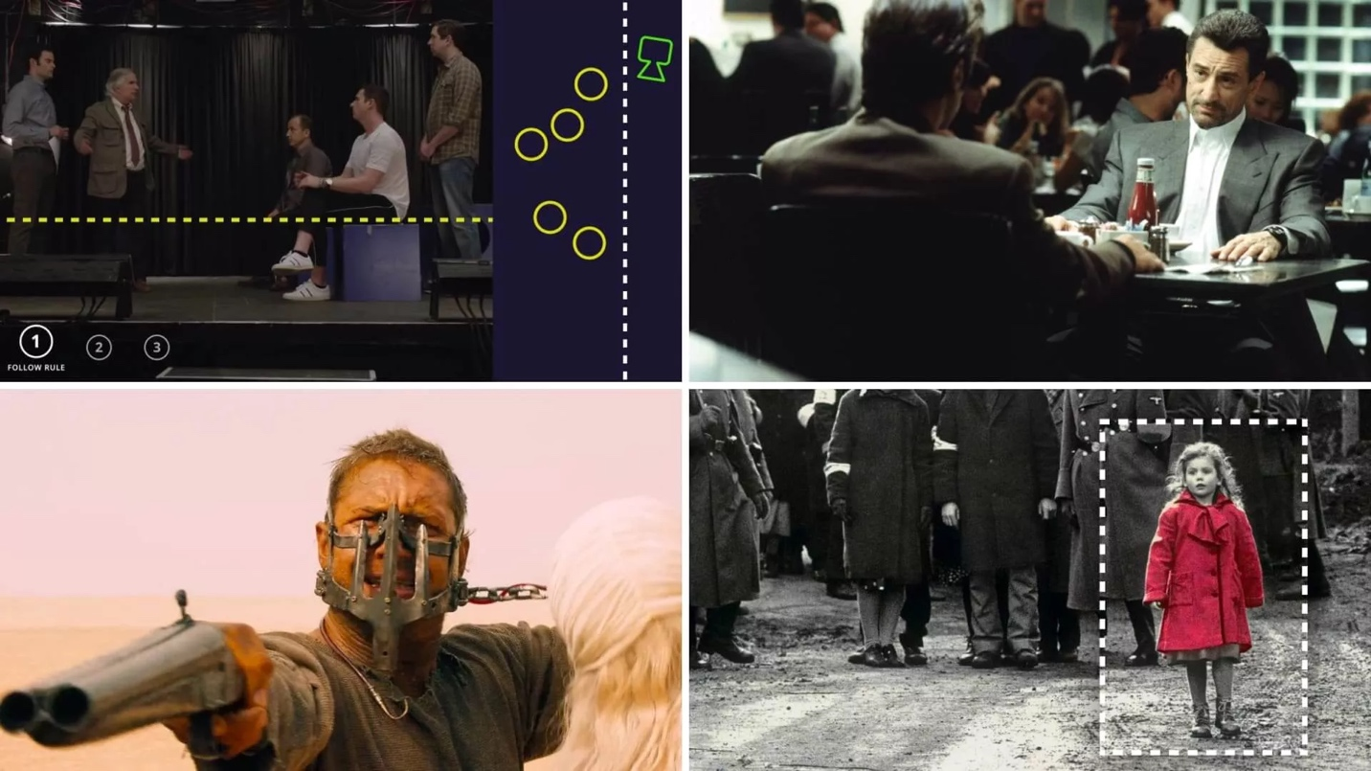
Figure 1: Editing Theory (Deguzman, 2021)

1.2.2 Sound Theory
Sound design plays a crucial role in making a TV commercial truly effective. By blending music, sound effects, and clever mixing techniques, it sets the mood and strengthens the brand's identity. When audio is balanced just right, with layers and smooth transitions like fade-ins and fade-outs, it creates a seamless listening experience. Adding sound effects, like swooshes or the sounds of product interactions, brings a sense of realism that makes the ad more engaging and unforgettable. (Hibbard, 2014)
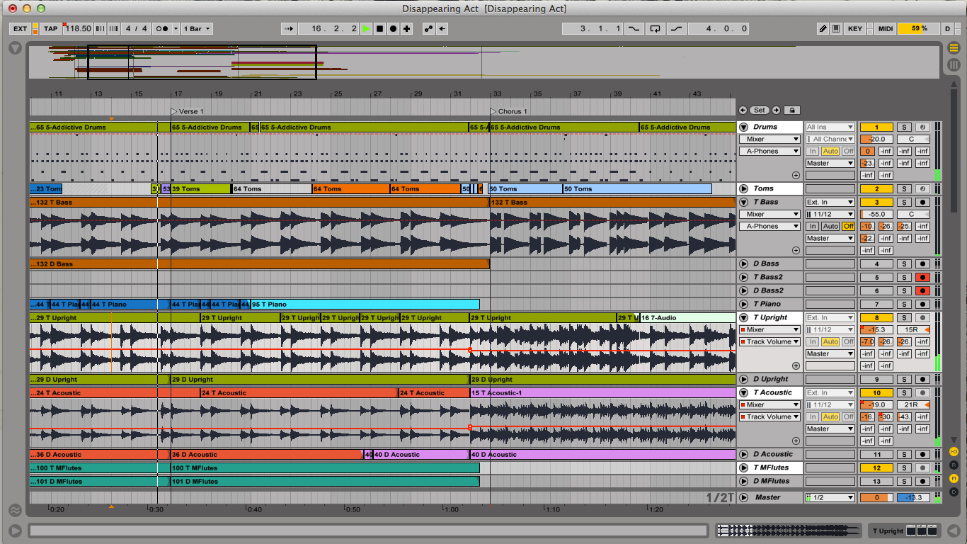
Figure 2: Sound Design Theory (Hibbard, 2014)

1.2.3 Camera Theory
Camera techniques play a crucial role in shaping how a product is viewed, directing the audience's focus through various methods like framing, angles, and shot types. Wide shots set the scene, medium shots strike a balance between the subject and its surroundings, while close-ups draw attention to the finer details of the product. Plus, techniques such as camera movement and perspective shots really amp up visual interest, making for a more engaging viewing experience. (Hellerman, 2024)
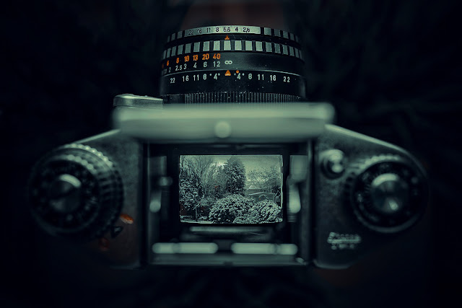
Figure 3: Camera Theory (Netti_Nu_Nu, n.d.)

1.2.4 Lighting Theory
Lighting plays a crucial role in setting the mood, clarity, and overall visual appeal of a product commercial. Using a three-point lighting setup, comprising key, fill, and backlight, helps achieve a well-balanced illumination and adds depth to the scene. High-key lighting gives off a bright and clean vibe, while low-key lighting introduces contrast and a touch of drama. It's essential that the lighting style you choose resonates with the brand’s identity and the emotional tone you want to convey. (Lannom, 2020)
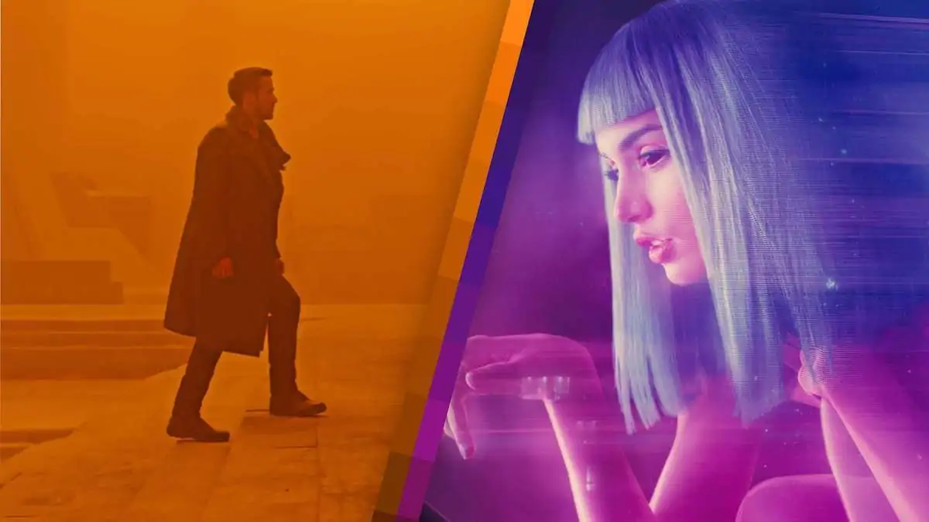
Figure 4: Lighting Theory (Lannom, 2020)

1.2.5 Emotional Influence and Consumer Engagement
Emotional appeal is crucial in advertising because it shapes how people relate to a product. Things like music, lighting, pacing, and camera angles work together to create a certain mood and stir up feelings like excitement or comfort. When these emotional signals align with the brand's message, it really strengthens the connection with the audience and boosts engagement. (Chi, 2023)

Figure 5: Emotional Influence and Consumer Engagement Theory

1.2.6 Colour Theory and Brand Identity
Colour plays a vital role in shaping how the visuals and brands are perceived. Different shades can trigger specific emotional reactions. Using colour grading, it enhance the mood, clarity, and consistency of our visuals, while tweaking brightness and contrast can make products stand out more. Warm colours often suggest energy, whereas cool colours tend to evoke a sense of calm, both of which can strengthen brand identity and visual impact. (Canva, n.d.)
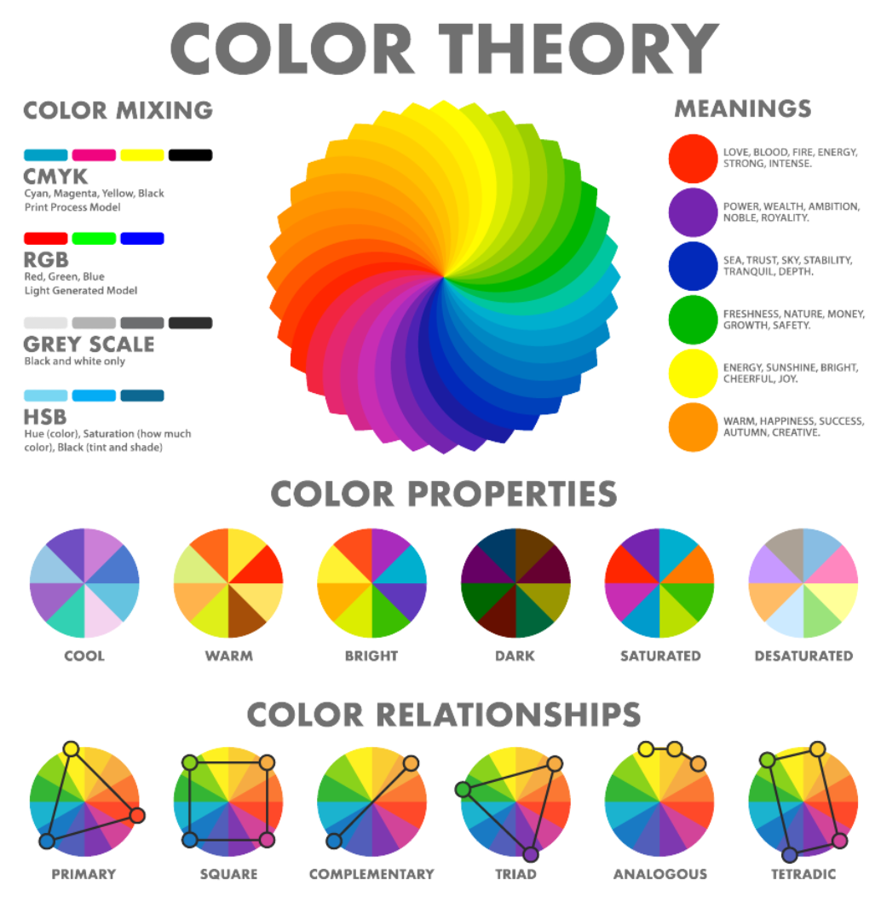
Figure 6: Colour Theory (codefinity, n.d.)

1.2.7 Visual Storytelling in Product Advertising
Visual storytelling in product advertising is all about blending technical skills with a captivating narrative to craft commercials that really grab attention. Rather than just showcasing the product, successful TV commercials demonstrate it in action or place it in familiar settings. By weaving together elements like cinematography, editing, sound, and colour, even brief ads can tell a powerful story that enhances brand identity and helps the audience remember it better. (Nikolaeva, 2017)
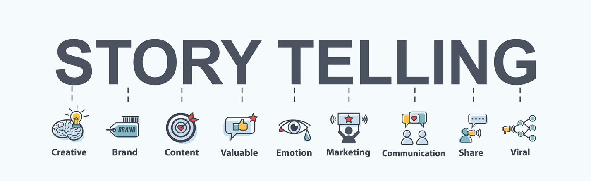
Figure 7: Visual Storytelling Theory (Skill Forges, 2023)

2. Aims of Project
The aim of this project is to produce a high-quality Product Shoot Television Commercial (TVC) for the MBT water bottle that effectively showcases its key features and lifestyle benefits. The project focuses on presenting the bottle as not only a functional product but also a stylish and essential everyday accessory.
The purpose of the TVC is to promote awareness of eco-friendly and reusable products while engaging a modern, digital audience. This is achieved through the use of fast-paced editing to capture attention, combined with slow-motion shots to highlight product details such as the built-in straw and material quality. Additionally, lifestyle-based scenes such as gym use, office environments, and outdoor activities help demonstrate real-life usability, making the product more relatable to the audience. These techniques work together to fulfil the project’s purpose of both informing and visually engaging viewers.

3. Target Audience
The target audience for this Product Shoot TVC mainly consists of people aged 16 to 35 who have active or laidback lifestyles. This group includes students, office workers, gym-goers, and outdoor lovers. They’re likely to connect with content on digital platforms like YouTube and Instagram.
From a cultural standpoint, the audience primarily consists of urban and semi-urban folks who have more modern lifestyles, global trends, and the way digital media is consumed. They're heavily influenced by social media platforms like Instagram and YouTube, where eye-catching quick content really grabs their attention. The product is crafted to be gender-neutral, appealing to both men and women equally, as its features and design cater to a wide array of tastes and daily habits. All in all, the advertisement is designed to connect with a digitally savvy crowd that appreciates both functionality and style in the products they choose.
The chosen target audience for this product is spot on, as people aged 16 to 35 are generally more engaged with digital ads and social media. This demographic tends to be more aware of sustainability and current lifestyle trends, making them perfect candidates for an eco-friendly reusable bottle.
Additionally, active folks like students, gym-goers, and outdoor lovers are likely to need a portable and sturdy water bottle in their everyday lives. By focusing on this audience, the TV commercial effectively markets the product to those who will truly appreciate its practical benefits, boosting the ad's overall impact.

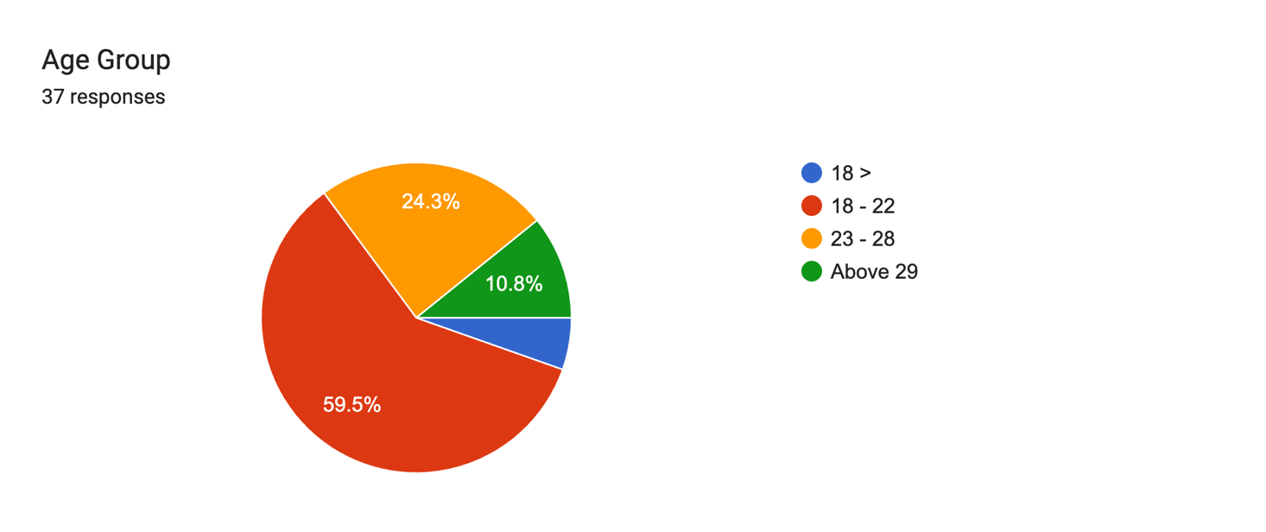
Figure 8: Age Group Survey
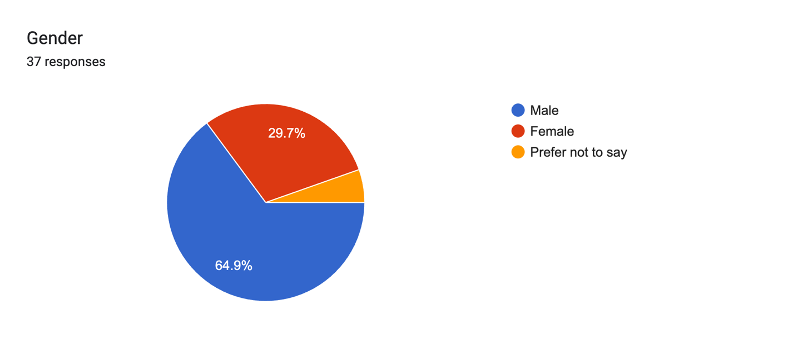
Figure 9: Gender Group Survey

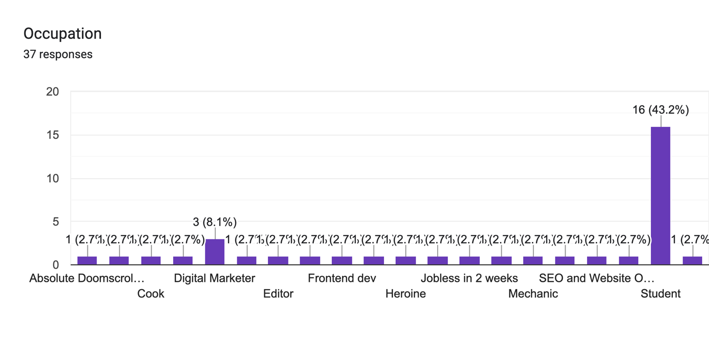
Figure 10: Occupation Group Survey
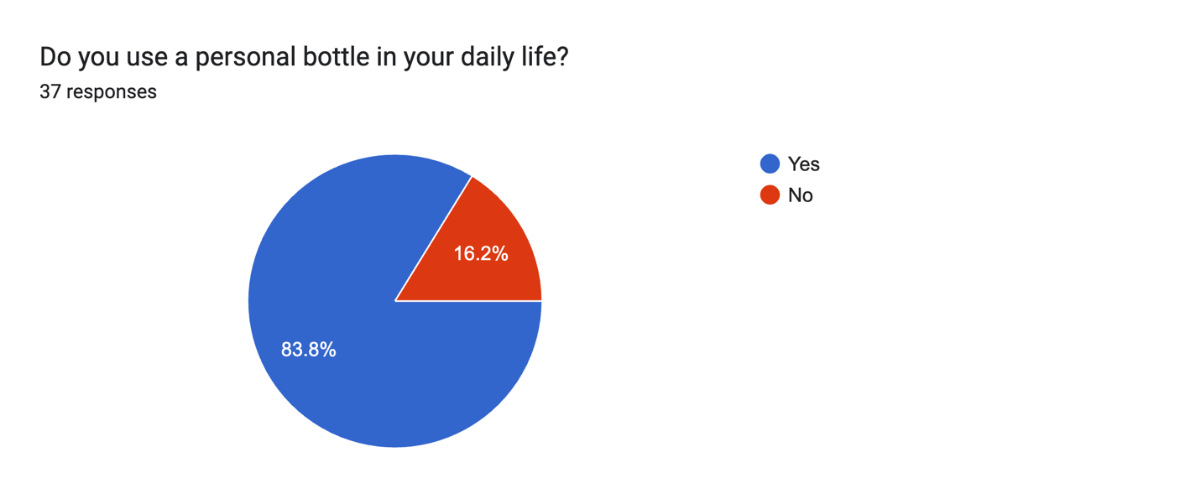
Figure 11: Personal Question Survey

4. Product Research
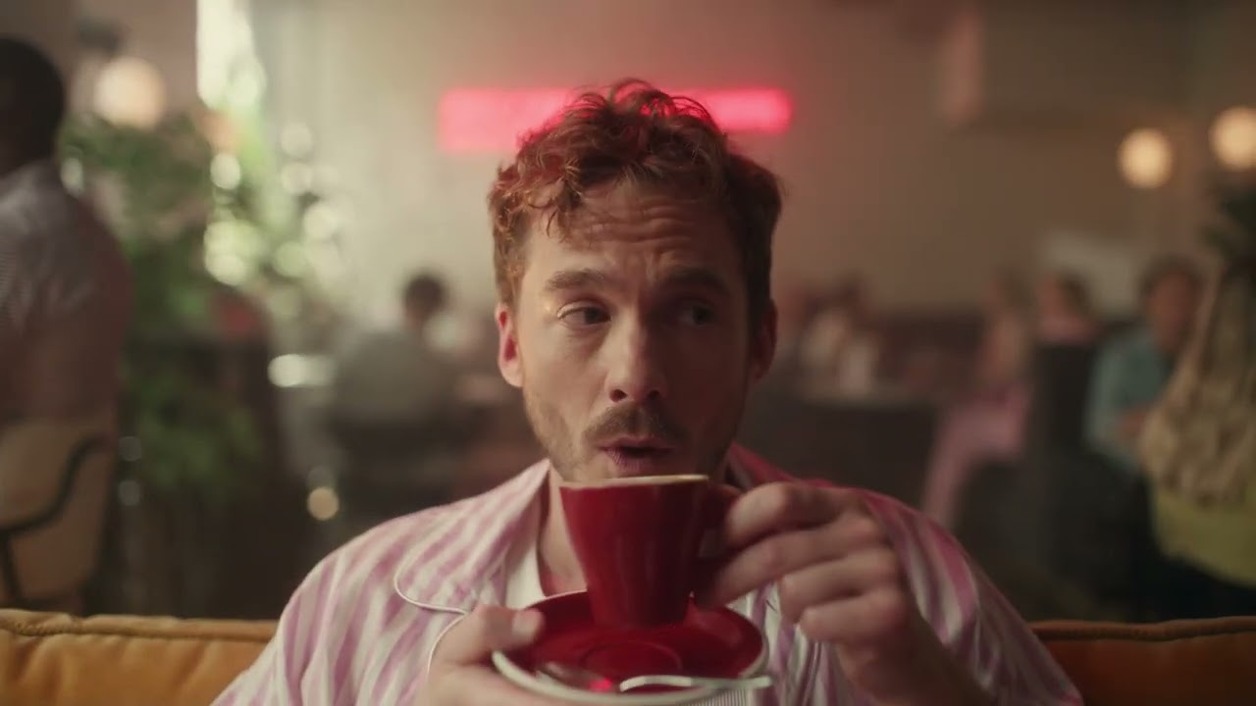
Figure 12: Thumbnail of Grind: This is better coffee
Video 1: Grind: This is better coffee.
The first reference video, “Grind: This is better coffee,” really showcased how powerful fast-paced editing and strong visual storytelling can be. The quick cuts and diverse scenes kept the audience hooked while effectively conveying the product’s essence. This inspired us to use dynamic editing techniques in our project, ensuring the advertisement stays visually captivating.
Good points:
- Clear message about what the product is about
- Has a clear CTA that it is a “better coffee”
- Scene changes to showcase it can be drunk on different scenarios
Bad Points:
- Pacing can be overwhelming for some people

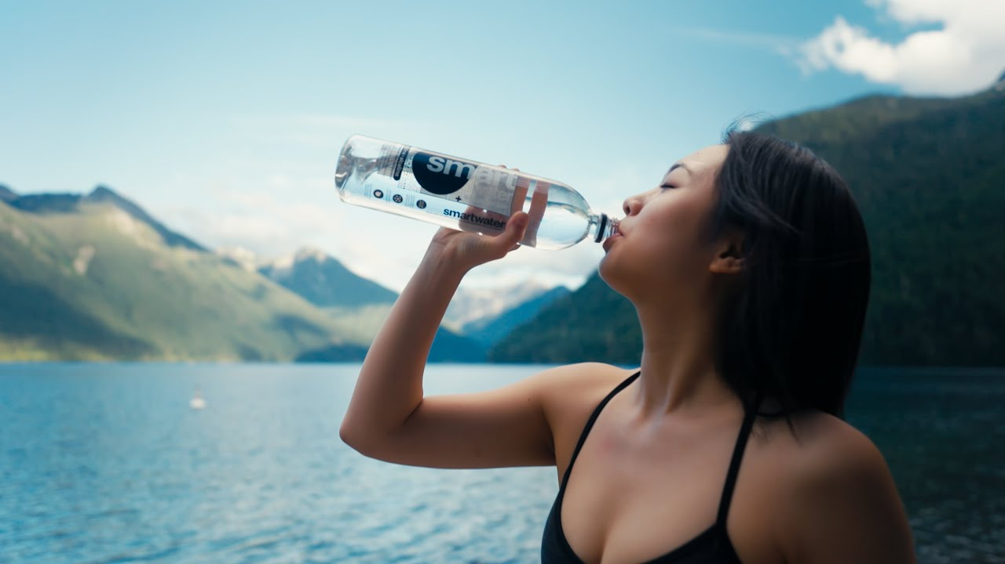
Figure 13: Thumbnail of a Cinematic Water Bottle Commercial
Video 2: a Cinematic Water Bottle Commercial
The second reference, a cinematic water bottle commercial, really emphasized how crucial high-quality visuals and colour grading are. The clean composition and those detailed close-up shots did a fantastic job of highlighting the product’s features. That said, the limited camera angles made the video feel a bit repetitive. With that in mind, the project aimed to incorporate a broader range of camera angles and movements—think close-ups, tracking shots, and slow-motion sequences—to make the final result more dynamic and visually captivating.
Good points:
- Has a lot of great visuals
- Colour grading is top notch
Bad points:
- The video has not been shot in other camera angles and only consists of one or two fixed camera angles.

5. Technologies Employed
Every software tool played a unique role in the production pipeline.

5.1 Davinci Resolve
DaVinci Resolve was utilized for colour correction and grading, helping to create a more visually consistent look and enhancing the overall appeal of the footage.

Figure 14: Logo of Davinci Resolve

5.2 Adobe Premiere Pro
Adobe Premiere Pro was used for editing and sequencing, to arrange clips, control the pacing, and produce the final video output.

Figure 15: Logo of Adobe Premiere Pro

5.3 Adobe After Effects
Adobe After Effects was used for creating mixed media visuals and doing motion graphics.

Figure 16: Logo of Adobe After Effects

6. Project Plan
The original plan was to do a studio-based product shoot with controlled lighting and minimal movement. But after running some test shots, it was realized that the concept didn’t really connect with a lifestyle vibe and didn’t showcase the product’s portability as well as hoped. Plus, the studio setup also didn’t work out as intended and many shots had to be reshot which ultimately led to the concept of outdoor shoot instead.
This included outdoor settings and real-life scenarios, like gym workouts, playing football, hiking, in the office, etc. This adjustment really helped make the product more relatable and engaging for the audience.
The production timeline had to be updated accordingly to fit in the new shooting locations and any necessary reshoots. A new Gantt chart was put together to reflect these updates, making sure it stayed on top of our time management and workflow efficiency.
The original Gantt chart had a few problems, like spending way too much time on planning and not enough on actual production. The shooting was confined to a studio, which made it less realistic. Plus, the post-production tasks, such as editing and colour grading, were rushed at the end, leaving little room for finalizing. The plan also didn’t allow for much flexibility since it didn’t factor in time for reshoots or feedback.
Figure 17: Old Gantt Charrt

To tackle these issues, the revamped Gantt chart brought in a more balanced and realistic workflow. It included outdoor shooting to enhance relatability, along with specific time set aside for test shoots and reshoots. Post-production was spaced out more evenly, which improved quality control, and a feedback stage was added to polish the final output. These adjustments made the whole process more efficient and led to a much stronger final product.
Figure 18: New Gantt Chart

7. Production Phases

7.1 Pre-production
This phase involved planning the concept, developing ideas, and creating a basic shot list. Decisions regarding locations, camera angles, and lighting setups were made during this stage and casting for the characters on the TVC were also conducted.

7.1.1 Script

7.1.2 Storyboard

7.2 Production
During the production phase, all the planned footage were captured using a mix of camera techniques. Close-up shots to really showcased the product details, while dynamic shots like tracking and handheld movements brought a dynamic energy to the visuals.
Various locations were used to film the product in real-life scenarios. This included scenes of the bottle being used during workouts, outdoor adventures, and everyday routines like in the office.
A few challenges were faced while filming. The main being lighting in outdoor settings; it was a bit unpredictable, which meant the camera settings had to be tweaked on the go. Plus, some shots needed to be redone because of framing issues and distracting background elements. Everyone involved also couldn’t be always available for all the shoot timings. Other challenges were tackled with retakes and adjustments right on site.

7.3 Post-production
Since the clips were shot on a LOG profile, the clips were graded using Davinci Resolve.
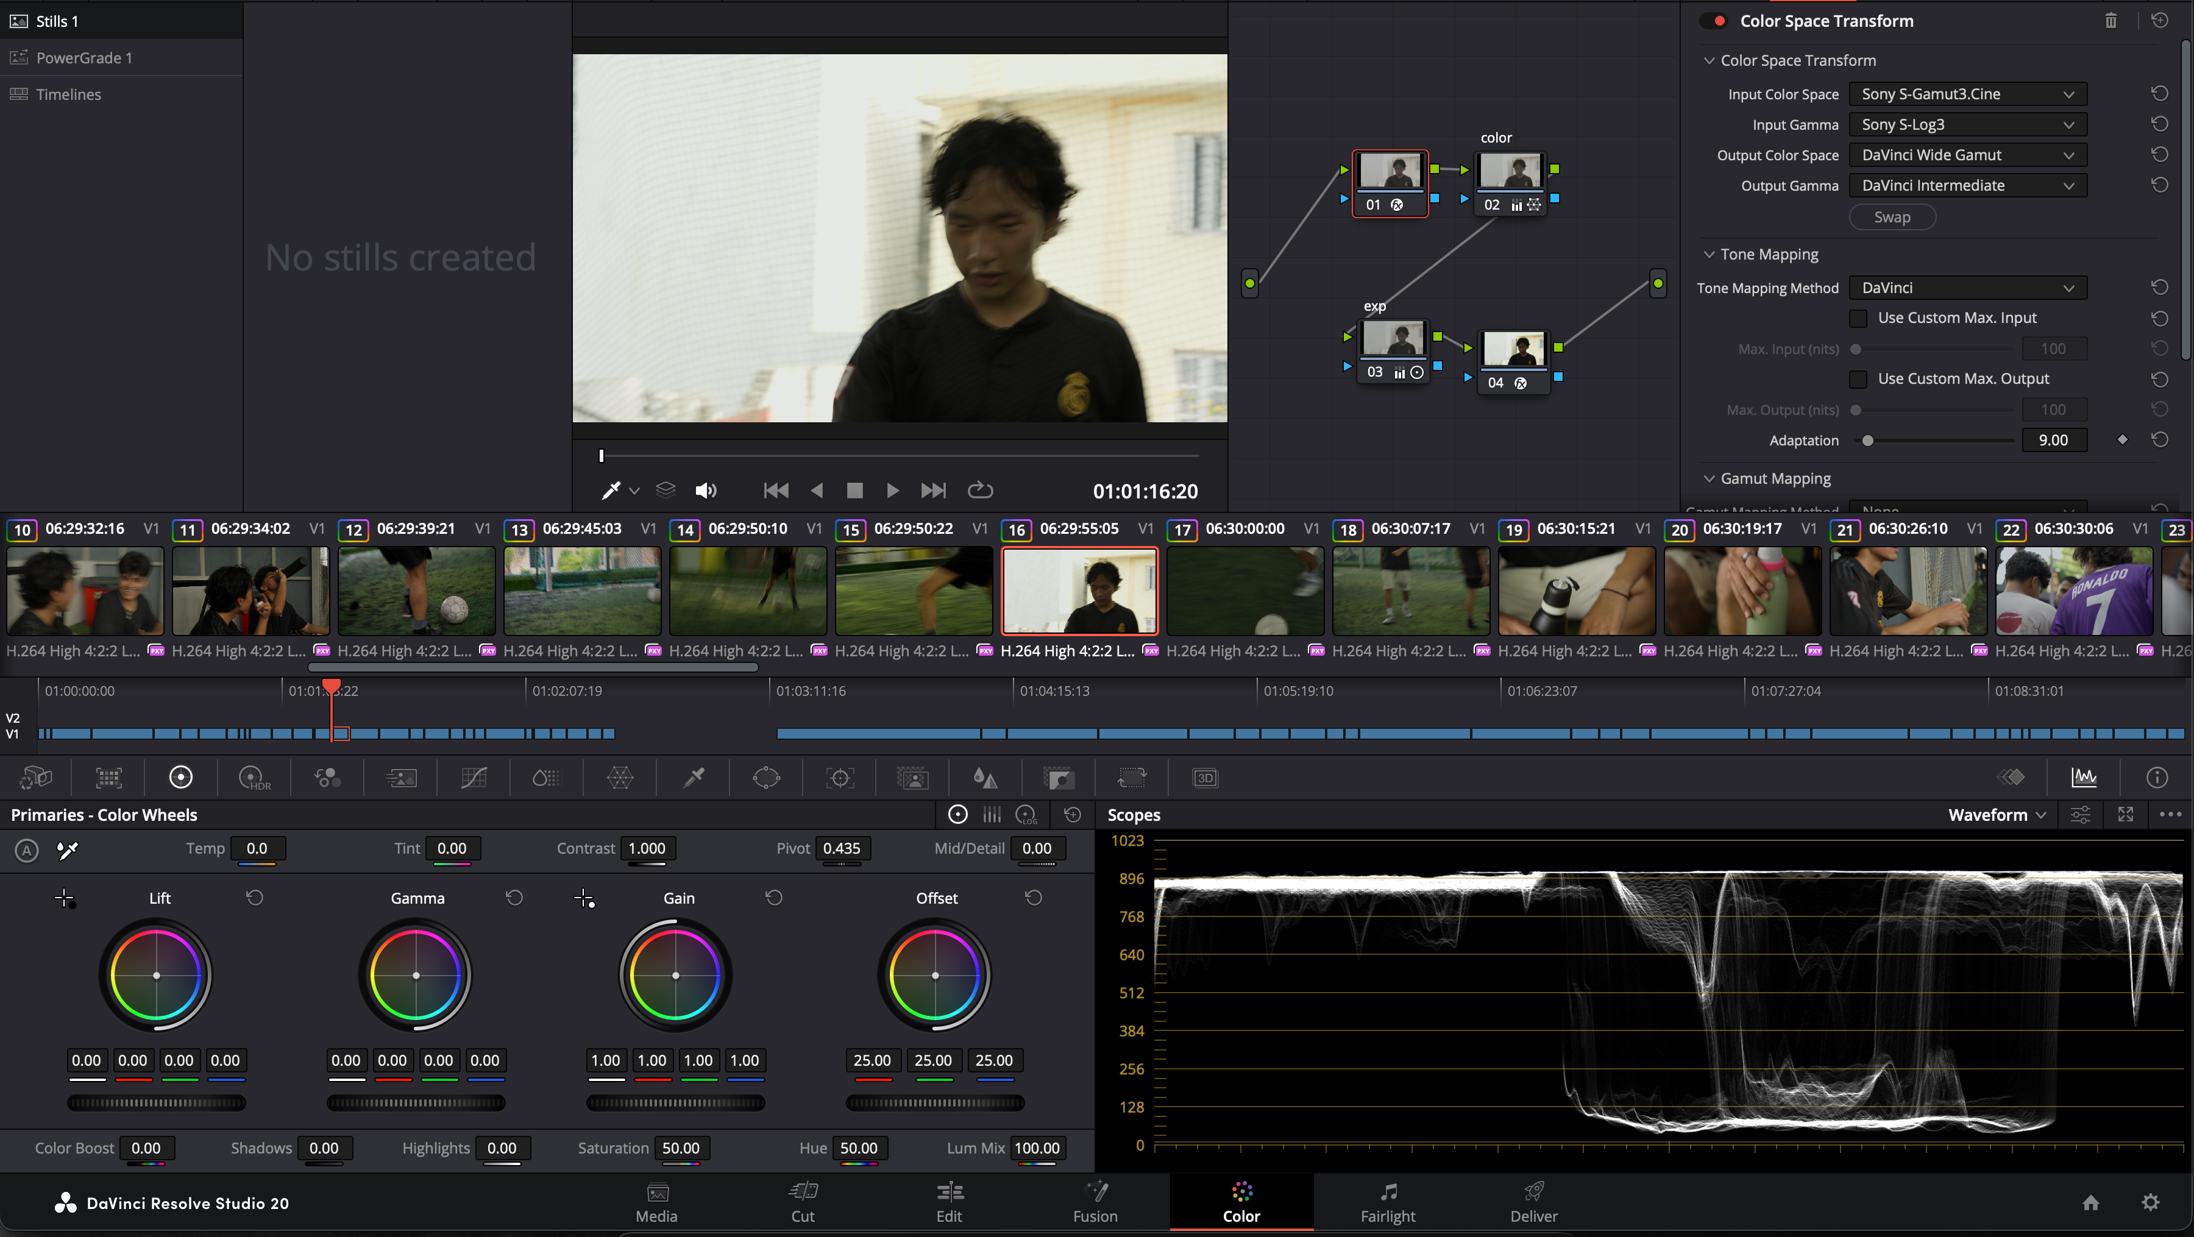
Figure 19: Colour Grading in Davinci Resolve

After all the clips were graded, the clips were exported and brought into Adobe Premiere Pro then compiled accordingly.
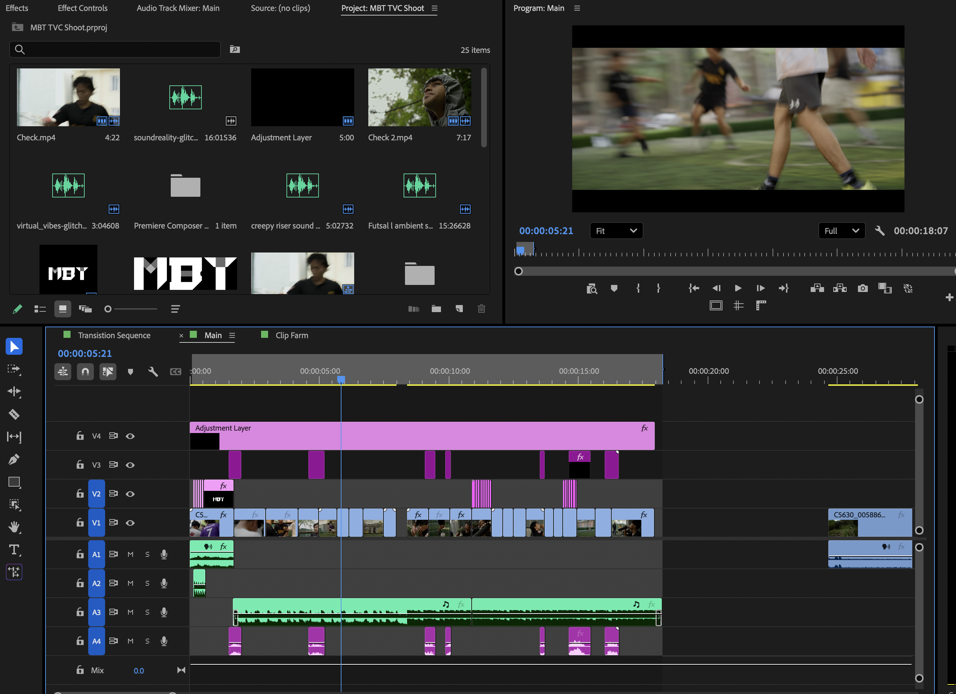
Figure 20: Editing in Adobe Premiere Pro

Feedback from peers was also considered to improve the final output.
mention the details on what steps were carried out in each phases along with images and screenshots to complete the entire project.

8. Resources
The project required both hardware and software resources. Hardware included the camera, lenses, gimbal, and basic lighting equipment. Software resources included video editing tools such as Adobe Premiere Pro.
Additional resources included online research materials, reference commercials, and feedback tools such as Google Forms for evaluation. These resources supported both the production and evaluation stages of the project.
The project required a combination of both hardware and software resources to ensure a professional production workflow. For hardware, a Sony A7IV camera was used, paired with lenses like the 24–105mm, 16–35mm, and 50mm to capture a wide range of shots.
In terms of software, Adobe Premiere Pro was used as the main editing tool for assembling and refining the video. Its features allowed for cutting and compilation, and audio adjustments to enhance the overall quality of the TVC. Additional resources included online research materials and reference commercials, which helped guide the creative direction and visual style of the project. Furthermore, tools such as Google Forms were used during the evaluation phase to collect audience feedback efficiently. These combined resources supported both the production and post-production processes, contributing to the successful completion of the project.
The final TV commercial is designed for sharing on digital platforms like YouTube and Instagram, as these sites match the viewing habits of our target audience.
Research k bata garey - youtube

9. User Testing & Findings
3 speaker, 3 monitor ma herda
Mention the Tests that were conducted among the users and mention the finding in detail in this section.

10. Conclusion
In conclusion, this project was achieved by creating a visually appealing Product Shoot TVC for the MBT water bottle. Many things were done including all the essential elements of digital media production, from research and planning to filming, editing, and evaluation.
By using cinematography techniques, editing principles, sound design, and colour grading, the final video really highlights the product’s features and the lifestyle benefits it offers. Plus, user testing was included to make sure the end result met both technical standards and audience expectations. All in all, this project showcases a solid grasp of media production processes and effective product advertising.

11. References
(Abreu, 2022)
(Canva, n.d.)
(Chi, 2023)
(Deguzman, 2021)
(Hellerman, 2024)
(Hibbard, 2014)
(Lannom, 2020)
(Netti_Nu_Nu, n.d.)
(Nikolaeva, 2017)
(Skill Forges, 2023)
(codefinity, n.d.)

12. Bibliography
Deguzman, K., 2021. What is Continuity Editing in Film? Definition and Editing Techniques. [Online]
Available at: https://www.studiobinder.com/blog/what-is-continuity-editing-in-film/
[Accessed 20 4 2026].
Hibbard, M., 2014. Sound Design 101: Making Your Film Sound Great. [Online]
Available at: https://www.premiumbeat.com/blog/sound-design-101-making-your-film-sound-great/
[Accessed 30 4 2026].
Abreu, R., 2022. What is Film Editing — Editing Principles & Techniques Explained. [Online]
Available at: https://www.studiobinder.com/blog/what-is-film-editing-definition/
[Accessed 30 4 2026].
Hellerman, J., 2024. 50+ Camera Angles, Shots, and Movements. [Online]
Available at: https://nofilmschool.com/camera-angles
[Accessed 30 4 2026].
Netti_Nu_Nu, n.d. Vintage camera, Camera, Viewfinder image. Free for use.. [Online]
Available at: https://pixabay.com/photos/vintage-camera-camera-viewfinder-6835351/
[Accessed 30 4 2026].
Lannom, S., 2020. Three-Point Video Lighting: Key, Fill, & Backlight Setup Guide. [Online]
Available at: https://www.studiobinder.com/blog/three-point-lighting-setup/
[Accessed 30 4 2026].
Chi, C., 2023. How Neuromarketing Can Revolutionize the Marketing Industry. [Online]
Available at: https://blog.hubspot.com/marketing/neuromarketing
[Accessed 30 4 2026].
Canva, n.d. Color theory and the color wheel. [Online]
Available at: https://www.canva.com/colors/color-wheel/
[Accessed 30 4 2026].
codefinity, n.d. Understanding Color Theory in Photoshop. [Online]
Available at: https://codefinity.com/courses/v2/c139005b-6c33-4e9b-bd4a-ccbe4195d169/672d2d8f-c56f-428a-926b-8e4f8aa5b11c/c716d833-2ec8-4307-8f09-458e5f4652ea
[Accessed 30 4 2026].
Nikolaeva, B., 2017. Visual Storytelling: What It Is and How to Do It Right. [Online]
Available at: https://graphicmama.com/blog/visual-storytelling/
[Accessed 30 4 2026].
Skill Forges, 2023. The Art of Visual Storytelling: Elevating Your Narrative. [Online]
Available at: https://skillsforges.com/blog/the-art-of-visual-storytelling-elevating-your-narrative
[Accessed 30 4 2026].

13. Appendix
Figure 21: Old Gantt Chart

Figure 22: New Gantt Chart
